الجمهورية اللبنانية
الاسم والشهرة:-----------------

رقم المرشح :-------------------
وزارة التربية والتعليم العالي الإمتحانات الرسمية لشهادة الإمتياز الفني
المديرية العامة للتعليم المهني والتقني لدورة عام 2017 الثانية
=========
الإختصاص والرمز : المعلوماتية الإدارية (23107)
المادة : طرائق التحليل المعدل : (12)
المستندات المسموح بها : لا شيء المدة : ثلاث ساعات

Treat the following exercises:

Exercise 1: Explain the difference between these two CDM and give the LDM of each of them. (2 pts)

a)

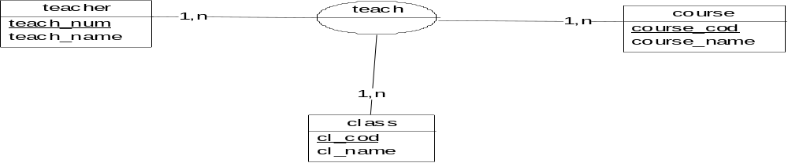

b)

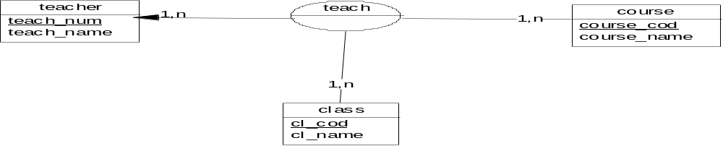

Exercise 2: Transform the following MCD to MLD. (4 pts)

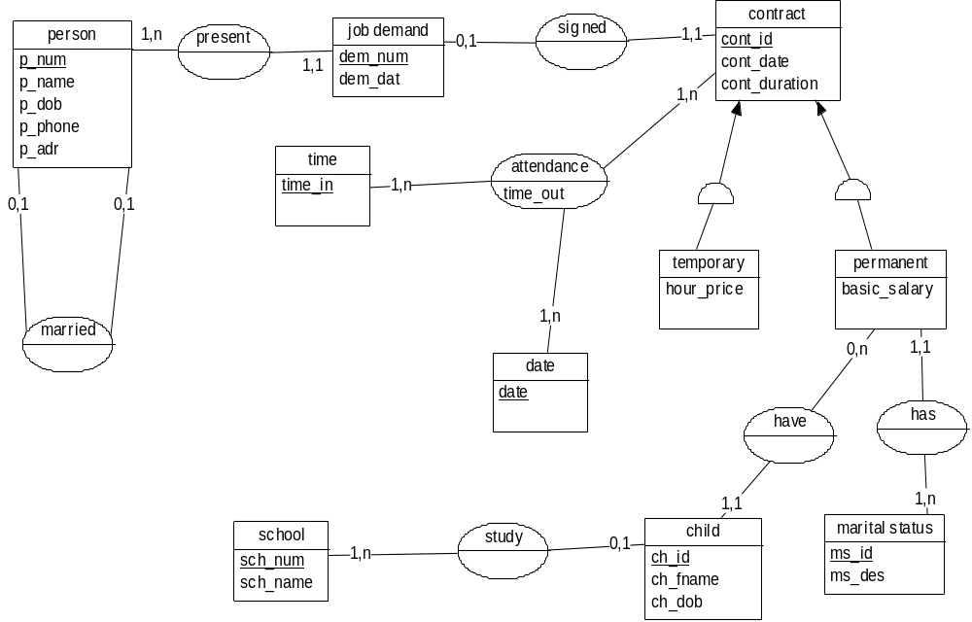

الإختصاص والرمز : المعلوماتية الإدارية (23107)
المادة : طرائق التحليل المعدل : (12)
المستندات المسموح بها : لا شيء المدة : ثلاث ساعات

Exercise 3: Case of a college.
We want to achieve the computerization of the weekly allocation of the rooms at the college, the management of the grades and the management of students’ absences during a school year.
The college is composed of 20 classrooms:
- 17 classrooms, some of which are equipped with the materials (projectors, screens, triple tables...) and have a capacity ranging from 30 to 45 seats.
- 2 laboratory rooms each of which has a capacity of 50 seats.
- A sports hall has a capacity of 150 seats.
The college manages 5 classes of 6 °, and 4 classes of 5°, 4° and 3°. Each class has a number and a name. Students from the same class follow the same course. The list of students in each class is set at the beginning of the year.
Each student has the following information: name, surname, date of birth, sex, address, phone, class name.

The courses are repeated identically in all the weeks of the school year. Each course has a number and belongs to a type of course. Each type of course has a coefficient for a class name.

A teacher can teach several classes.
Each teacher has the following information: teacher number, teacher name, sex, date of birth, mobile phone, email, nationality, degree, year of graduation, university, country and specialization.

To indicate a course to a room and a teacher, we want to ensure that the teacher doesn’t have a course at the same time in other class.
A course is provided by a single teacher. Some teachers offer several types of courses (French, Latin...).

There are no common courses to several classes. Some courses require specific hardware (video, projectors, screens …). We admit that the assignments are decided for one year: a course (spotted by a day, an hour and a teacher, ex: Monday 10 h, Mr X) takes place in the same room and the same class every week.

According to the management of the notes, after each exam (exam number, exam date, exam name, exam coefficient) the grades are entered. The reports of grades are printed at the end of each semester.

According to the managing of absences, the current manual processing is the following: a daily attendance sheet, marked with the number of the week and the name of the day, circulates from a teacher to another during the day. When the administration is notified of an absence of a student before starting of a course, it writes the mention "Excused" on the line of the student, for each relevant course. The daily attendance sheet returns to the direction at the end of the day to enter it. All unjustified absences are object of a mail addressed to parents, indicating the days and hours of the absence. A student may be absent in a course without being absent on the day. An absence to a single course may be justified in advance (see dentist...).

Work to do :
- Build the data dictionary. (3 pts)
- Determine the entities by specifying identifiers and properties. (3 pts)
- Achieve the corresponding CDM. (4 pts)
- Identify the processes and build the CTM for each. (4 pts)

